ILLICIT DISCHARGE ELIMINATION PLAN (IDEP) 2014 Application
Submitted in partial fulfillment of the State of Michigan National Pollutant Discharge Elimination System Permit Application for Coverage of Storm Water Discharges by:

GENESEE COUNTY PHASE II PARTICIPANTS

Phase II Permittees:
Burton; Clio; Davison; Davison Township; Fenton; Fenton Township; Flint Township; Flushing; Genesee Township; Grand Blanc; Linden; Mount Morris; Mount Morris Township; Swartz Creek; Vienna Township; Genesee County.
Nested Jurisdictions under Genesee County Permit:
Atherton Community Schools | Fenton Area School | Lake Fenton Schools
Beecher Community Schools | Flint Board of Educations | Linden Community School
Bendle Public Schools | Flushing Community Schools | Mt. Morris Consolidated Schools
Bentley Community Schools | Genesee Schools District | Swartz Creek Community Schools
Carman Ainsworth Community Schools | Genesee Intermediate School District | Westwood Heights Schools
Clio Area Schools | Grand Blanc Community Schools
Davison Community Schools | Kearsley Community Schools | Bishop Airport*
The Bishop Airport property is nested under Genesee County’s permit for their storm water runoff only. They also have an industrial discharge permit for their other activities.
The Municipal Separate Storm Water Discharge Permit requires that all MS4s develop an illicit discharge elimination plan (IDEP). The above communities have entered into a 342 agreement with the Genesee County Drain Commissioner’s office (GCDC) to assist them with their stormwater needs. As part of the contracted agreement the GCDC will be conducting the IDEP activities required by the permit on behalf of the communities and nested jurisdictions. This plan is submitted on behalf of all of the above communities and nested jurisdictions. It outlines the approach to be used to meet their IDEP obligations. The major components of the Genesee County IDEP plan include field verification of outfall locations, reviewing and eliminating illicit discharges, reviewing the legal authority, minimizing seepage from septic systems and sanitary sewers, and the coordination of activities.

Reviewing the Legal Authority
Legal authority for the management & elimination of illicit connections and discharges stems from two state authorities. The first is the Michigan National Pollutant Discharge Elimination System (NPDES) permit (MIG60000) which enables local communities to grant themselves the authority to regulate, prohibit, investigate, monitor and enforce illicit connects and discharges. The 342 permitted communities have been provided with an ordinance template that addresses each of these requirements that they can tailor to their own situation and then adopt it into their local code. Individual permittee legal authority is under a separate document.
The second legal authority stems from the Michigan Drain Code of 1956, Section 280.423, which grants the Genesee County Drain Commissioner (GCDC) the authority to prohibit illicit discharges. Section 280.421, which grants removals of obstructions in County Drains. And Section 280.424, which provides for the state commissioner of health to petition the Drain Commissioner’s office. These authorities applies to all legally established county drains. The relevant sections from the Michigan Drain Code is Attachment A.

The third legal authority is the Genesee County Health Department (GCHD), which governs septic systems only.
The fourth legal authority stems from PA 283 of 1909, section 19b. which requires a person, partnership, association, corporation or governmental entity to acquire a Permit for work within a county road from its Road Commission. Work would include connecting storm water outlets within the Road ROW. The relevant section is attached.
The GCDC together with local community representatives has reviewed the current legal authority and enforcement procedures. The County storm water ordinance template will provide local municipalities with the authority (once adopted) to prohibit illicit discharges and manage outfalls for all municipal drainage systems. Attachment “C” is the section out of the template ordinance that covers legal authority to prohibit illicit discharges.
The BMP subcommittee has been working on developing the Stormwater Ordinance, which includes the authority to detect and eliminate illicit connections and discharges to the permittee’s MS4. Pursuant the COCs, the Stormwater Ordinance Template was submitted to the MDEQ for review under the revoked 2008 permit. Outline of events for adoption of the ordinance/resolution:
Aug 11, 2010: Meet with MDEQ, to go over comments and concerns.
October 11, 2010: make necessary changes and submit copy to MDEQ.
March 8, 2011: MDEQ withdrew 2008 permit
2014 Permit application required communities to adopt ordinance. Townships may do so as a resolution.

Field Verification of Outfall Locations
The outfall map section of this plan is based on field investigation conducted in the previous permit cycle together with permittee records. Although a majority of the collection systems was surveyed in the first permit cycle not all outfalls have been field verified. The IDEP plan approved under the previous permit used a different approach to locate and field verify outfalls. The IDEP crews walked the waters of the state within Genesee County and located all outfalls whether they were MS4’s or private. With the 2008-2013 permit cycle, only MS4’s are being identified. The outfalls that are being identified and screened are all MS4s where they are going from permitee jurisdiction into the waters of the state and discharge points between two permitee MS4 jurisdictions. Note: Genesee County’s permit covers several agencies and nested jurisdictions. A single outfall identified under the County’s permit may contain multiple discharge points between agencies or nested jurisdictions covered under the same permit. An important part of this cycles IDEP work will be to continue to field verify the location of mapped outfalls. Additionally, ownership (municipal MS4 or private) will be determined for each outfall. Maps are being continually updated, but are available in a shapefile version (GIS). Electronic copies are available and were provided to the MDEQ upon request in 2010 and an updated version November 2011. Yearly outfall updates are prepared and submitted within the progress report.
All known outfalls and discharge points for each community (except Burton and Genesee County) have been identified. Genesee County’s agencies and nested jurisdictions combined have more than 1,500 categorical discharges that are being identified. City of Burton took over the roads from the Genesee County Road Commission in the last 10-years. This has provided a significant larger number of outfalls under the City of Burton’s jurisdiction than originally anticipated. Identification of the outfalls for Burton Roads has been complicated by not all roads having maps.
All outfalls identified as of April 1, 2014 are located in attachment 1. If all outfalls are not identified a plan is included on how they will be identified prior to Oct 1, 2014. A shape file of the outfalls and storm systems are available. As outfalls are added/ removed, specific location(s) for additional outfall(s) will be reported as needed. Changes will be reflected in an updated map to be included in the progress reports.

Prioritizing Areas for Dry Weather Flow
Areas to be dry weather flow tested first are prioritized based on the permit application (page 5) and other criteria listed below. Before Oct 1, 2014 all known outfalls will be evaluated based on the criteria below be ranked as high, medium or low priority and the basis for that ranking. Dry weather testing will be done based on the schedule below and geography to maximize resources and to reduce travel time, proximity of outfalls to one another will be taken into consideration. Copies of the updated outfalls with the priorities will be available to the State upon request.
NOTE: Individual Permittees that opt to follow a alternative procedure for dry weather testing will need to provide to the State their procedure that would supersede this one.
High Priority | Areas with older infrastructure  Industrial, commercial, or mixed use areas  Areas with a history of past illicit discharges  Areas with a history of illegal dumping  Areas with onsite sewage disposal systems  Areas with older sewer lines or with a history of sewer overflows or cross-connections  Areas with poor dry-weather water quality  *Areas with water quality impacts, including waterbodies identified in a Total Maximum Daily Load  Verification of Categorical Outfalls (previously unmapped ?& never tested)  Discharge complaints and reports
Medium priority | Other potential pollutant generating sites  Type of commercial activity  Areas with sewer conversions or historic combined sewer systems
Low priority | Undeveloped area  Subdivisions less than 30 years old with no know history of illicit discharge  Confirmed illicit discharge that has been removed  Upstream Discharge points that are already being sampled at the outfall regardless of jurisdiction unless a suspected illicit discharge is found
No priority | Non urbanized outfalls that were included under past permits
*The only TMDL in Genesee County is for ecoli. The outfall would only be considered high priority under this choice if it had the potential of discharging ecoli.

Schedule: outfalls to be dry weather tested
2015 | High priority outfalls for Municipalities 60% complete, Genesee Co 10% complete
2016 | High priority outfalls for Municipalities 95% complete, Genesee Co 25% complete
2017 | High priority outfalls for Municipalities 100% complete, Genesee Co 50% complete Medium priority outfalls for Municipalities 50% complete, Genesee Co. 10% comp
2018 | High priority outfalls for Genesee Co 75% complete  Medium priority outfalls for Municipalities 100%, Genesee Co. 60%
2019 | High priority outfalls for Genesee Co 100% complete  Medium priority outfalls for Genesee Co. 100%  Low priority outfalls will be done in 2020-2025 permit cycle
Although the outfalls will be completed at the end of the 5-year IDEP cycle the year-to-year schedule is subject to adjustments due to weather, financial considerations and staff availability.
*Prior to October 1, 2014 a list showing the priority level of each outfall will be provided to the State.

Performing Dry-weather Screening
As mentioned above, one of the primary actions under the IDEP program is to identify and remove all illicit discharges and connections from the municipal storm sewer system. The outfall maps presented in Attachment 1 of the 2014 application is in ArcView GIS and this information will be updated and added to for guiding the screening of outfalls for dry weather flow.
To achieve IDEP requirements, each outfall that is prioritized High or Medium will be screened for signs of illicit discharges. Where illicit discharges are suspected, systematic investigation upstream of the outfall will be conducted to trace the discharge to the source where practicable.
*Genesee County outfalls include all County agency and nested jurisdiction outfalls. A single outfall identified under the County’s permit may contain multiple discharge points between agencies or nested jurisdictions covered under the same permit. Only the County agency/ nested jurisdiction at the point of outlet will be indicated on the outfall table. The PA 342 Contract acts as a interagency agreement.

The process of locating and removing illicit connections is illustrated in an attached Work Plan Flow Chart. The flow chart is discussed in detail below. Forms for recording field inventory information and observations if dry weather flow is observed are also included at the end of this section. The dry weather screening form could be used multiple times at a single site if a suspected connection or discharge requires follow-up site visits.
The High or Medium outfall will be observed in the field during dry weather conditions, 72 hours with less than 0.10 inches of rainfall, and the sites will be checked for intermittent flows if suspected. If flow is present, it will be visually observed, checked for odors, and tested for representative tracer parameters such as pH, temperature, E. coli, fecal coliform, detergents, ammonia, and total organic carbon. The thresholds for the above parameters that trigger activity to determine the sources of illicit connections are listed below. All of these tests, except for pH and temperature, will be performed by a professional contract laboratory. Test results and observations will be used to identify areas that require follow-up investigations.

Parameter | Threshold
Ammonia (NH₃) | 1 mg/l
Surfactant | .2 mg/l
E.coli. | 2000 Col. Per 100 ml
Ph | 7 - 9

Decision Making
Depending upon the type of illicit discharge there are various responses that can occur. The following chart outlines the appropriate responses to an illicit discharge based upon whether they are spills and emergencies or illicit connection.

 |  |  | Illicit Discharge
Spills & Emergencies  (isolated dump of pollutant into water) |  |  |  | Illicit Connection  (Pipe connection to water)

Dry weather testing performed
Pollutant identified & tracked upstream to source
No one knows it is happening |  | Incident is reported
No response |  | 911 is called by public:  Fire Dept  Hazard response team  Police  Emergency Mgmt.  Local Municipality  SESC enforcing agency  MDNRE  Dry weather testing performed as needed by GCDC  Local Community/ Police can ticket or assess costs of cleanup against dumper. |  | Source found through  IDEP or public reporting  Notify the following departments:  Health Dept  Local Municipality  GCDC Surface Water  MDNRE  Source eliminated |  | Source not found  Source tracked to the furthest extend practicable.  Follow-up testing scheduled
Depending on the type and location of an illicit discharge, the responsible party can change. In a spill or emergency, 911 should be called to initiate the emergency response. As an illicit discharge is identified and information is gathered, the responsible party will be identified from the above bulleted list.
The following are examples of the types of materials that if discharged constitute a spill or an emergency due to the potential introduction of pollutants to local waterways either directly or through stormwater: dredged spoils, solid waste (see below), sewage, garbage, sewage sludge, munitions, chemical wastes, biological materials, radioactive materials, heat sources, wrecked or discarded equipment, rock, sand, petroleum products, industrial, municipal, and agricultural waste. This list is not meant to be exhaustive. The quantity of the spill should also be considered in conjunction with the type of spill that has occurred before reporting it. For example, wastewater from painting activities need not be reported to 911 but one may wish to mention it to the authorities such as public works, or the GCDC to have them contact the offender in order to educate them.
Illegal dumping: permitee will make sure 911 has been contacted, who will contact fire dept, police, emergency management and the hazardous response team. Local responder will depend on the nature of the discharge (see above) and if a responsible party is identified. If a responsible party is identified, a private cleanup company may be involved. MS4 owner is enforcement agency for follow up. (local municipality, County, MDNRE).
Illicit sanitary connection: once identified, GCDC will contact the Heath Dept, local community, MS4 owner and MDNRE by letter. Enforcement agency for follow up is Health Dept, coordinated with GCDC.
Failing soil erosion measures: MS4 owners are the enforcement agency once construction is complete and the soil erosion permit has been released. If the site is a current construction site, the permitee will make sure the presiding SESC agency has been notified pursuant section 9107 of Part 91 and fill out a spill form. If there is an active SESC permit then the presiding SESC agency is the enforcement agency.
Large quantity spill: permitee will make sure 911 has been contacted, who will contact fire dept, police, emergency management and the hazardous response team. Local responder will depend on the nature of the discharge and if a responsible party is identified. If a responsible party is identified, a private cleanup company may be involved. MS4 owner is enforcement agency for follow up. (local municipality, County, MDNRE).
In all the above instances, if a responsible party is not identified, and if the spill is significant enough to warrant clean-up, measures will be taken to address the problem by local authorities to levels that at a minimum ensure public safety. The decision to commence with a clean-up will be made by whoever has jurisdiction over the spill site. In some cases there maybe multiple jurisdictions in which case all parties will be consulted on the course of action to occur. For all significant spills, the MDEQ will receive verbal notification of the event within twenty-four (24) hours.
Within Individual communities, if an emergency spill is received, this person will make sure that the call gets resolved or forwarded to the responsible agency.
- Davison Township DPW Director
- Fenton Township Ordinance Enforcement Officer
- Flint Township Building Dept Agent
- Genesee Township Code Enforcement Officer
- Mt. Morris Township Code Enforcement Officer
- Vienna Township Building Superintendent
- City of Burton DPW Director
- City of Clio City Administrator
- City of Davison Clerk/DPW
- City of Fenton DPW Director
- City of Flushing DPW Supervisor
- City of Grand Blanc Public Works Director
- City of Linden DPW Director
- City of Mt. Morris DPW Superintendent
- City of Swartz Creek DPW Director
- Genesee County GCDC-SWM Drain Engineer

Illicit Source Identification
GCDC-SWM has been contracted to coordinate the dry weather testing and perform any follow up on behalf of the Contracted Phase II communities and nested jurisdictions listed on the first page of this document. When initial testing has identified a potential problem, it will be given to the GCDC office staff to follow up and confirm an illict connection or not. The land use and type of buildings in the area will be considered to determine the next course of action. Based on the land use and the results of the observations and chemical testing, additional manholes will be investigated. Tracing of the pollutant stream will continue by manhole investigations until the source is isolated within a relatively short reach of sewer. Dye testing of building fixtures will then be used to locate the source.
Dye testing will be scheduled by GCDC staff at individual buildings following notification of the building owner to explain the need for this investigation and how it will be performed. In general, dye testing will be used as the final step to gain positive identification of an illicit connection. Televising the sewer may be used to further isolate the pollutant source or may be used if dye testing does not reveal the source of the problem. This approach is intended to locate illicit connections is the most cost-effective and efficient manner possible. It will focus the use of dye testing in those areas with the highest potential for illicit connections.
Field investigations to identify specific illicit connection locations will be performed by either the GCDC or a consultant contract. If a source is found discharging to a municipal’s or nested jurisdiction’s MS4 that is not owned by Genesee County, GCDC will also notify owner, elected official (supervisor, mayor or superintendent) or in the case of the airport the facilities manager for assistance to perform the tracking and elimination of the illicit discharge. If a source is found discharging to a Genesee County MS4, GCDC will also notify the appropriate agencie(s) for assistance to perform the tracking and elimination of the illicit discharge.
Illicit discharges to MS4 systems other than the County’s, 342 communities and nested jurisdictions that are discovered will result in the generation of a letter to the owner/operator informing them of the problem. If it is a confirmed illicit discharge the MDEQ will be copied on the letter.
Occasionally, hot spots are located that may threaten local water quality. Stormwater hot spots are areas where current or legacy land uses or activities generate contaminated runoff, with concentrations of pollutants exceeding those typically found in stormwater. A typical example is an abandoned underground storage tank associated with a gas station. If a suspected hot spot comes to the attention of GCDC they will develop a plan to monitor the hot spot and the surrounding area, with in their capacity, to determine the degree and extent of the problem and the threat (if any) it may pose to local waterways and public health. Appropriate action will then be taken as limited by the availability of funds.

When potential illicit connections are located, the GCDC will be provided with specific details by the consultant/ field investigator.The GCDC will be responsible for coordinating the tracking of an illicit connection upstream to its source and elimination. Once an illicit connection has been confirmed a letter to notify the property owner / responsible party and other involved parties (including the municipality, MS4 owner and the MDEQ) of the violation and require corrective action by the property owner or responsible party. If the illicit connection is time sensitive or beyond the jurisdiction of this program (such as an industrial discharge), an e-mail may be sent in lieu of a letter. Once the confirmed illicit connection has been eliminated a follow-up letter will be sent to all involved parties.

Eliminating Illicit Discharges and Pursuing Enforcement Action
Prioritization of verifying and removing potential illicit connection is done through a combination of when they are initially detected (chronologically) and by geographical location (trying to maximize resources through scheduling investigation that are close to each other). If the property owner does not respond in the specified time frame, follow-up enforcement action will be taken by GCDC or the appropriate enforcing agency. Each problem is unique and depending upon the circumstance. When the property owner or responsible party has indicated that a connection has been eliminated, GCDC will confirm that all problems have been fixed to their satisfaction for both the County Departments, nested jurisdictions and 342 communities.
GCDC and its partners will work to eliminate all illicit discharges to the maximum extent practicable. This means exhaustive steps will be taken within the limits of financial and technical resources available to address the problem. Occasionally, elimination of the source is not possible either because it cannot be found or the cost to address the problem exceeds the benefits of making the correction. In these cases either a management plan will be implemented and/or the location identified for regular monitoring by the owner/operator.

Updated maps are provided in the progress reports that reflect ownership, status of any illicit connections found, as well as corrections to the original information in the permit.

Public Notification System for Illicit Discharges
Currently the Illicit Discharge system is split between those that are associated with illegal dumping and those releases associated with MS4s. The above flow chart illustrates the various paths and responsible parties involved in managing Illicit Discharges.
The number of possible ways that an illegal dumping can occur compounded by the number of agencies involved make centralization of this function extremely difficult and cost prohibitive under the current economic climate. Furthermore, centralization of the function may in-fact reduce response time and clean up efficiency due to having to educate the public about the who they should call. Current laws do not provide for a single responsible party.
The permit requires the permitee to develop and implement a procedure for the receipt and consideration of complaints or other information submitted by the public regarding construction activities discharging waste to the MS4.
The M&M Subcommittee had already created a form to be used to track illegal dumping as reported by the public, similar in concept to a “chain of custody” from used to track hazardous materials. The form originates with the agency that receives the call from the public and end with GCDC. This way illegal dumping calls will be responded to as they are received. Calls will continue to be prioritized by the type of suspected release. For example, from the responder’s perspective a suspected oil spill will take precedent over a suspected detergent spills. Another benefit to improving the current system is that it allows local communities under current laws to levy fines and collect clean-up costs if the responsible party can be identified.
The illicit dumping form will direct the originating agency to notify GCDC within 24 to 48 hours and inform them of any corrective action taken. This way GCDC can track any open notification that still may need to be followed up on as well as determine any apparent patterns that may lead to eliminating re-occurrences in the future.
The permit requires the permitee to develop and implement a procedure to provide notice to the part 91 permitting entity and the Department when pollutants are discharged in violation of section 9116 of Part 91 (SESC rules). The requirement of notice of violation has already been required in section 9107 of Part 91. A new procedure is unnecessary.
Note: minor changes to the spill form have been done to include SESC information to notify of SESC complaints.

Minimizing Seepage from Septic Systems and Sanitary Sewers
A map of the sanitary sewer service areas was prepared in 2006 for the watershed plan to define areas where sanitary service is available and septic tanks can be prohibited. Those areas with possible septic tanks are included in the watershed management plans. As part of the actions in the Watershed Management Plan, Genesee County will explore the possibility for a time of sale septic tank inspection ordinance and coordinate such activities with the County Public Health Department.
GCDC Water and Waste Services (WWS) has a PA 342 Water and Sewer Advisory Board (WSAB) with their water and sewer community customers. The WSAB have a sanitary sewer infiltration and inflow removal program (I&I Program). This program is being enforced by both GCDC-WWS and the local communities that use the WWS treatment plants. Since 2001 there has been a significant effort to reduce I&I through monitoring flows between communities, lining sanitary lines, locking sanitary lids, waterproofing structures, footing drain removal and other efforts by all parties. This has resulted in a wet weather reduction to the treatment plants. There has also been a reduction on sanitary sewer overflows due to wet weather. WWS has also focused on efforts to the infrastructure and treatment plants to build in non-wet weather capacity.

Training
At the start of every IDEP field season training is conducted for new Tetra Tech employees, summer interns, GCDC personnel and individuals from various other firms and municipalities. The training is typically for an entire day and provides procedural information for individuals that have not previously been involved in IDEP operations, and it serves as a refresher for the regular IDEP field crews. There is both an in-class module and a field demonstration. Through the use of Power Point presentations, IDEP protocol manuals, and hands on training in the field, individuals are given the tools to collect and record the required data under the Phase II Storm Water permit.
At a minimum the following topics are covered:
The definition of illicit discharges and connections
Techniques for finding illicit discharges, including field screening, source identification, and recognizing illicit discharges and connections
Methods for eliminating illicit discharges and the proper enforcement response
A training schedule and requirement for training during the term of the permit
Additional topics usually include:
The methodology that will be utilized by the municipality to find, prioritize and eliminate illicit discharges and connections to the municipal separate storm sewer system (MS4)
The IDEP investigation history for the municipality
Desktop assessment of illicit discharge potential within the municipality, including assessment of the highest priority investigation areas based on the prioritization criteria listed in Table 1 of the permits
Investigation planning and preparation for field work
Field techniques that can be used to detect and identify the sources of illicit discharges/connections.

Training for staff that have field jobs
For staff that do not actually perform Dry weather flow, but do work in field jobs that would have the potential for them to witness illicit discharges and connections, a information sheet is being developed. See Attachment C. This will be provided to appropriate staff per IDEP training and evaluation (#18) requirements in the 2014 application and can be used to train staff.
An information sheet on signs of an illicit discharge, see attachment – will be provided to staff per IDEP training and evaluation (#18) requirements in application. We will provide the training/literature on the following schedule:
For Genesee County’s permit, the information in attachment C of this document (How to spot illicit discharges, A tip card for Municipal Staff) will be distributed to each agency and nested jurisdiction. They will be required to train their staff internally once each permit cycle or within 1-year of new hire at a minimum. Each agency/ nested jurisdiction will be responsible for keeping its records and reporting annually to the GCDC-SWM to be included in the implementation reports to the State.

Some Departments Such as Parks and Recreation, do annual training of all their employees. This will be included in their annual training.

Effectiveness of IDEP program
The current permit requires that the permitee determine the effectiveness of their illicit discharge elimination activities. These evaluation activities are in addition to inspecting each high and medium storm water point source every five years. GCDC will use three evaluation methods, all of which are approved methods in the MDEQ IDEP guidance. The current GCDC IDEP program will continue to compare the number of illicit discharges/connections eliminated versus the number found and report these in the annual report. The second evaluation method is to use the illicit discharge tracking form for public generated complaints. Information collected will be reported in the progress reports. The last evaluation method to be used is the ambient water quality monitoring results generated yearly from the existing program. Project Green, FRWC’s Benthic Monitoring, monitoring conducted for IDEP investigation and any additional hot spot monitoring are updated and analyzed annual.

Progress Report
GCDC together with its member permitees will provide documentation of the actions taken to eliminate illicit discharges. For identified illicit discharges, the permitees shall summarize the total estimated volume and pollutant load eliminated for the main pollutants of concern, and the locations of the discharges into both the permitees MS4 and the receiving water.

Coordination of Activities
The Genesee County Drain Commissioner will be coordinating with all municipalities, county agencies and nested jurisdictions to address illicit connections/discharges, local ordinances, and seepage from septic systems and sanitary sewers. This work is proposed to be performed under a PA 342 contract with Genesee County. All work is proposed to be directed by the Drain Commissioner and coordinated with the Road Commission, Health Department, Emergency Management Services, and local officials, as appropriate. Annual discussions on IDEP matters will be placed on 342 committee of the whole meetings.

Record Keeping
Permitees shall make records associated with IDEP activates to address illicit discharges and connections available to the MNRE upon request.

DRAINAGE SYSTEM INVENTORY
GENERAL ID __________________________
Date __________ Time __________
Crew Initials __________ Chk By: __________
Photographs: Roll #__________ Picture #’s __________

DISCHARGE STRUCTURE TYPE

PSD
Manhole
Catch Basin
Culvert Outlet
Point in Open Channel
Abandoned
Unknown

PSD Status

PSD
Not a PSD
PSD Not in Permit (New)
PSD Not Permittable
Structure within Drainage Network

LOCATION (see back side for location sketch)
Latitude
Longitude
Invert Elevation
Offset Description:

Receiving Waterbody: _________________________________________________________________

DISCHARGE SRUCTURE INFORMATION
Pipe ID
Direction from MH

N

Shape
Diameter (in)
Width (in) (Open Channel)
Depth (in)
Measure Down (ft) (Manhole)
Invert Elevation (ft) (Pipes)
Conduit Material
US/DS End

Comments
LOCATION SKETCH
LOCATION SKETCH CHECK LIST
Label Street Names
Indicate North
Locate manholes by dimensions from property lines, back of curb, or edge of pavement
Sketch catch basins and connections (no measurements necessary).
Indicate (if possible) distance to upstream and downstream manholes
Landmarks/nearest address, if any
Flow direction
Sample point
Special access/traffic control notes
Between mile markers _____ & _____ or _____ tenths past mile marker _____
Velocity/depth measure location

DRAINAGE SYSTEM SCREENING
GENERAL ID __________________________
Date __________ Time __________ Air Temp __________ Rain Yes No Clear/Sunny
Crew Initials __________ Chk By: ___________ Partly Cloudy
Photographs: Roll #__________ Picture # __________ Overcast

DRY WEATHER FLOW PRESENT

Yes, Dry Weather Flow Present
Trace, Insufficient
No Dry Weather Flow Present
Standing Water
Submerge
Inundated
N/A

FLOW MEASUREMENTS
Pipe Sampled: Size (in) ___________ Direction ___________
Method: | Tt Method | General Data |  |  | Travel
 | Area * Velocity | Depth, (in) |  |  | Time Trials
 | Bucket | Dist Traveled, (ft) |  | #1 (sec)
 | Manning’s | Bucket Vol, (l) |  | #2 (sec)
 |  | Channel Slope (%) |  | #3 (sec)
 |  | Channel Material |  | Avg (sec)
Flow: |  | Channel, n |  | Vel (fps)
Intermittent Not Checked
Flow Check Left Sand Bag in Channel
Removed Sand Bag, intermittent DWF present Yes No
if possible describe frequency, duration, time of day of flow slugs – put in comments section

DISCHARGE OBSERVATIONS (if “other” checked fill in description at bottom of page)
Odor | None | Musty | Sewage | Rotten Egg | Gas | Oil | Other
Floatables | None | Trash | Sewage | Bacterial Sheen | Oil Sheen | Suds | Other
Deposits/  Stains | None | Mineral | Sediment | Oily | Grease | Suds | Other
Vegetation | None | Normal | Excessive | Algae | Slime |  | Other
Structural | Normal | Cracking | Spalling | Corrosion | Settlement | Staining | Other
Color | _________ | Enter #
Turbidity | _________ | Enter #

Description:
RECEIVING WATER OBSERVATIONS (if “other” checked fill in description at bottom of page)
Odor | None | Musty | Sewage | Rotten Egg | Gas | Oil | Other
Floatables | None | Trash | Sewage | Bacterial Sheen | Oil Sheen | Suds | Other
Deposits/  Stains | None | Mineral | Sediment | Oily | Grease | Suds | Other
Vegetation | None | Normal | Excessive | Algae | Slime |  | Other
Bank | Excessive Vegetation | Staining of Banks | Erosion | Trash |  |  | Other
Color | _________ | Enter #
Turbidity | _________ | Enter #

Description:

DRAINAGE SYSTEM SCREENING (Continued)

ID __________________________

CHEMICAL ANALYSIS
FIELD ANALYSIS LAB SAMPLE COLLECTED ID _____________

Surfactants |  |  |  | mg/L | Temperature
Ammonia |  |  |  | mg/L | pH
Boron |  |  |  | mg/L | Specific Cond. | __________
Potassium |  |  |  | mg/L
E. Coli |  |  |  | per 100ml

RESULTS
Illicit Connection Ruled Out
Illicit Connection (undocumented connection)
Pending
Notify City
Not a PSD

ACTION
None Required
Illicit Removed
Waiting on Lab Results
Dye Test
Televise
Investigate Further
Illicit Connection

Comments
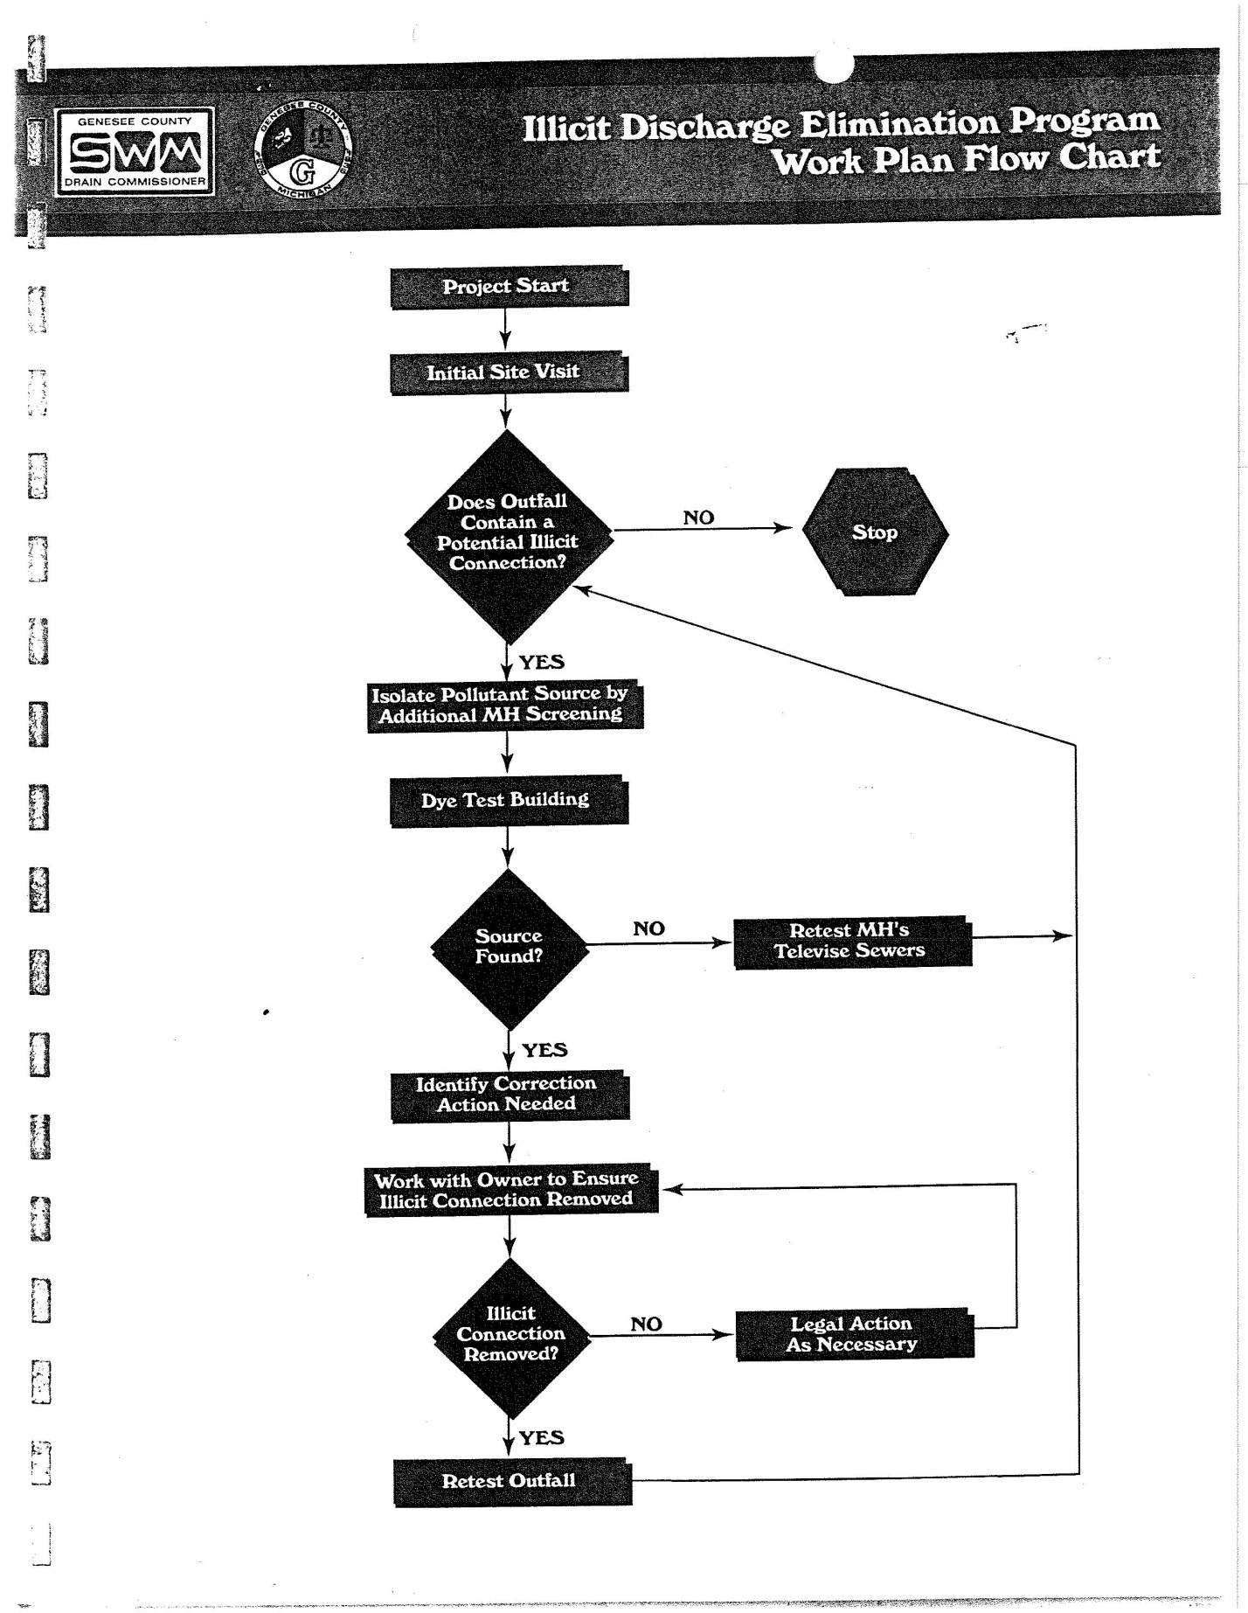
Michigan Drain Cod5 eff. 1956
Attachment “A” Drain Code excerpt
Attachment “B” PA283 of 1909 excerpt
Attachment “C” *How to spot Illicit Discharge Brochure
Attachment “D” Memo to GCDC-SWM staff
Attachment “E” Spill Notification

Attachment “A”
DRAIN CODE

280.423 Discharge of certain sewage or waste matter into drains prohibited; construction to purify flow; petitions; order of determination; findings; construction of drain; plans and specifications; contracts; costs; review; acquisition of land; application and fee for sewer connections; connections; powers of drain commissioner or drain board; failure to comply with section; violation as misdemeanor; fine; “person” defined.
Sec. 423. (1) A person shall not continue to discharge or permit to be discharged into any county drain or intercounty drain of the state any sewage or waste matter capable of producing in the drain detrimental deposits, objectionable odor nuisance, injury to drainage conduits or structures, or capable of producing such pollution of the waters of the state receiving the flow from the drains as to injure livestock, destroy fish life, or be injurious to public health. This section does not prohibit the conveyance of sewage or other waste through drains or sewers that will not produce these injuries and that comply with section 3112 of part 31 (water resources protection) of the natural resources and environmental protection act, Act No. 451 of the Public Acts of 1994, being section 324.3112 of the Michigan Compiled Laws.
(2) Disposal plants, filtration beds, and other mechanical devices to properly purify the flow of any drain may be constructed as a part of any established drain, and the cost of construction shall be paid for in the same manner as provided for in this act for other drainage costs. Plants, beds, or devices may be described in the petition for the location, establishment and construction of drains or in the petition for the cleaning, widening, deepening, straightening, or extending of drains, or in the application for the laying out of a drainage district. Petitions for the construction of plants, beds, and devices for use on any
established drain may be filed by the same persons and shall be received and all proceedings on the petitions in the same manner as other petitions for any drainage construction under this act.
(3) If the department of environmental quality determines that sewage or wastes carried by any county or intercounty drain constitutes unlawful discharge as prescribed by section 3109 or 3112 of part 31 of Ad No. 451 of the Public Acts of 1994, being sections 324.3109 and 324.3112 of the Michigan Compiled Laws, that 1 or more users of the drain are responsible for the discharge of sewage or other wastes into the drain, and that the cleaning out of the 'drain or the construction of disposal plants, filtration beds, or other mechanical devices to purify the flow of the drain is necessary, the department of environmental quality may issue to the drain commissioner an order of determination identifying such users and pollutants, under section 3112 of Act No. 451 of the Public Acts of 1994, being section 324.3112 of the Michigan Compiled Laws. The order of determination constitutes a petition calling for the construction of disposal facilities or other appropriate measures by which the unlawful discharge may be abated or purified. The order of determination serving as a petition is in lieu of the determination of necessity by a drainage board pursuant to chapter 20 or 21 or section 122 or 192 or a determination of necessity by a board of determination pursuant to section 72 or 191, whichever is applicable. A copy of the findings of the department shall be attached to the order of determination which shall require no other signature than that of the director of the department of environmental quality. Upon receipt of the order of determination, the drain commissioner or the drainage board shall proceed as provided in this act to locate, establish, and construct a drain. If the responsible users of the drain are determined to be public corporations in the drainage district, the drain commissioner or the drainage board shall proceed as provided in chapters 20 and 21, as may be appropriate, using the order of determination as the final order of determination of the drainage board. If the responsible users are determined to be private Persons, the drain commissioner shall proceed as provided in chapters 8 and 9, using the order of determination as the first order of determination.
(4) Plans and specifications for the construction as part of a drain of any disposal plant, filtration bed, or other mechanical device to properly purify the flow of the drain shall be prepared by the drain commissioner or the drainage board. Contracts for construction shall be let in the manner provided in this act. To meet the cost of any preliminary engineering studies for the construction of abatement or purification facilities, the drain commissioner or the drainage board shall apportion the cost among the several parcels of land, highways, and municipalities benefited thereby in the same manner as provided in chapter 7 or against the public corporations affected by the order of determination in the sane manner as provided in chapters 20 and 21. The costs and charges for maintenance shall be apportioned and assessed each year. If the apportionment is the same as the last recorded apportionment, a day of review' or a hearing on apportionments is not necessary, but if tire apportionment is changed, notice of a day of review or a hearing on apportionment shall be given to each person whose percentage is raised.
(5) Land may be acquired as a site for the construction of such plants, beds, and devices, and releases of land may be obtained in the same manner as provided in this act for other lands acquired for right of way.
(6) A person shall not connect sewage or other waste to a county or intercounty drain except with the written approval of the appropriate commissioner or the drainage board indorsed upon a written application for such service and the payment of a service fee of not to exceed $50.00 for each connection to a covered drain. The application shall include information showing that all other local, state, and federal approvals related to the sewage or waste have been obtained.
(7) The fee provided for in subsection (6) shall be set and collected by the drain commissioner, as approved by the county board of commissioners or the drainage board, and deposited with the county treasurer, to be credited to the drain fund set up for the maintenance or construction of the drain. The commissioner or the drainage board shall keep a record of applications made and the action on the applications. The commissioner or the drainage board may reject applications for or require such modification in requested applications for sewer connections to county drains as necessary to attain the objectives set forth in this section.
(8) Subject to the review and approval of the department of environmental quality, the drain commissioner or drainage board may study the requirements of persons for flood control or drainage projects including sewage disposal systems, storm sewers, sanitary sewers, combined sanitary and storm sewers, sewage treatment plants, and all other plants, works, instrumentalities, and properties useful in connection with the collection, treatment, and disposal of sewage and industrial wastes or agricultural wastes or run-off, to abate pollution or decrease the danger of flooding. The objective of such studies shall be that sewers, drains, and sewage disposal facilities are made available to persons situated within the territorial limits of any drainage district or proposed drainage district as necessary for the protection of public health and the promotion of the general welfare.
(9) The drainage board or drain commissioner may cooperate, negotiate, and enter into contracts with other governmental units and agencies or with any public or private corporation including the United States of America, and to take such steps and perform such acts and execute such documents as may be necessary to take advantage of any act of the congress of the United States which may make available funds for any of the purposes described in this section.
(10) Failure to comply with any of the provisions of this section subjects the offender to the penalties described in section 602. However, for each offense, a person who violates subsection (6) is guilty of a misdemeanor punishable by a fine of not more than $25,000.00 or imprisonment for not more than 90 days, or both. In addition, the person may be required to pay the costs of prosecution and the costs of any emergency abatement measures taken to protect public health or the environment. Payment of a fine or costs under this subsection does not relieve a person of liability for damage to natural resources or for response activity costs under the natural resources and environmental protection act, Act No. 451 of the Public Acts of 1994, being sections 324.101 to 324.98106 of the Michigan Compiled Laws.
11) As used in this section, "person" means an individual, partnership, public or private corporation, association, governmental entity, or other legal entity.
History: 1956,Act 40, Imd. Eff. Mar. 28,1956 ;--Am. 1972,Act 298, Imd. Eff. Dec. 14,1972;--b.1996, Act 60,Imd.Eff. Feb. 26,1996 ;-Am. 1996,Act 552, Eff. Mar. 31,1997.
280.421 Obstructions; removal; expenses, notice; livestock; criminal complaint.
Whenever any person shall obstruct any established drain, it shall be the duty of the commissioner to cause such obstruction to be removed. Any lessening of the area of a drain, which area shall be a cross section of the drain, shall be deemed to be an obstruction. The person causing such obstruction shall be liable for the expense attendant upon the removal thereof, together with the charges of the commissioner, and the same shall be a lien upon the lands of the party causing or permitting such obstruction, and all of the expense shall by the commissioner be reported to the board of supervisors, together with the report of his doings in the premises, and by said board ordered spread upon the land of the offending party, should the same remain unpaid: Provided, That the offending party causing such obstruction shall be given a notice in writing of at least 5 days to remove such obstruction. This provision as to obstruction of any drain shall not apply where the obstruction was caused by natural causes, but the owner of the stock who shall permit his horses, cattle, pigs and other stock to obstruct any drain by tramping in it shall be deemed to be the party causing such obstruction. Nothing contained in this section shall in any way impede or bar the right of any person to make criminal complaint under any existing law for any obstruction of a drain.
History: 1956, Act 40, Imd. Eff. Mar. 28, 1956
Popular Name: Act 40
280.424 Inadequate disposal or filtration plant; abatement of nuisance; estimate of annual cost; appeal; notice; posting; review of apportionment; board of review; meeting; proceedings; determination; payment; assessment; water rates.
Whenever a disposal plant, filtration plant or other mechanical device to purify the flow of such drain or sewer has been heretofore constructed, but is inoperative or improperly operated and, in the opinion of the state commissioner of health, the public health is endangered by reason thereof, said state commissioner of health may file with the judge of probate of the county in which said facilities are located, a petition reciting his findings and recommendations as to how the menace to health may be corrected or the nuisance may best be abated and how the improperly operated or inoperative disposal plant, filtration plant or other mechanical device to purify the flow of a drain or sewer should be operated. Upon satisfying himself as to the reasonableness of said recommendations, it shall be the duty of the judge of probate of said county to direct the drain commissioner of said county to prepare a plan for and estimate the annual cost of executing the recommendations of the state commissioner of health, and/or of rehabilitation, ordinary maintenance and operation of said improperly operated or inoperative facilities, to prepare a map showing the extent of the area contributing to said condition, and to make a determination of the annual expense thereof apportioned according to benefits to the state highways, cities, villages and townships benefited by the same. Upon receipt of the map, tentative assessment district and other information from the county drain commissioner, the judge of probate shall give notice of said facts and of the date of receiving appeals by publication in at least 2 insertions in some newspaper published and of general circulation in the county, if there be one, the first publication to be at least 10 days before the date set for receiving appeals and said notice shall also be posted at least 10 days before the date for receiving appeals in 5 or more conspicuous places in each city, village and township, where any part of the district may be located and within the limits of such district.
The state highway commissioner or any city, township or village which may feel aggrieved by the apportionment of benefits so made by the drain commissioner may make an application to said probate court for review of the apportionment by a board of review by filing with said probate court a notice of appeal. Only 1 board of review shall be appointed by said court. Upon receipt of any such notices of appeal, as hereinbefore provided, the probate court shall forthwith notify the drain commissioner, in writing, of such appeal and thereupon make an order appointing 3 disinterested freeholders of such county, not residents of said district, to constitute such board of review. The court shall thereupon, with the concurrence of the drain commissioner, immediately fix the time and place when and where said board of review shall meet to review said apportionments, which said time shall be not less than 10 nor more than 15 days from the date of filing such appeal.
The drain commissioner shall thereupon give notice to the persons so appointed of their appointment and of the time and place of meeting and shall give notice of such meeting by posting notices in at least 5 public places in each city, village and township forming a part of the drainage district and shall serve a like notice upon the state highway commissioner and each of said cities, villages and townships. Such service shall be made not less than 5 days before hearing. Return shall be made by the person serving said notice and shall be filed in the office of the judge of probate. At such hearing the board of review shall have the right and it shall be their duty to review all apportionments made by the drain commissioner. Persons appointed on said board of review shall be sworn by the drain commissioner to faithfully discharge their duties as members of said board.
The board of review shall proceed at the time and place specified in the notice to hear the proofs and allegations of all parties in respect to the matter of appeal. A review of apportionments shall be made by the board of review and if, in their judgment, there shall be manifest error or inequality in such apportionments, they shall order and make such changes therein as they shall deem just and equitable. Determination of the drain commissioner, if not appealed from, or of said board, in case of an appeal, shall be final and there shall be no right of appeal from such determination, except by writ of certiorari to the proper court. The determination shall be reduced to writing and signed by the drain commissioner, or in case of appeal a majority of the board making the same, and shall be delivered to the judge of probate together with all other papers relating thereto. Upon the apportionments becoming final, as hereinbefore set forth, the judge of probate shall deliver said approved roll of apportionments of benefits and expense to the drain commissioner, who shall assess the amounts therein set forth to the respective cities, villages and townships involved, and said cities, villages and townships shall thereafter make payment thereof as collected in quarterly installments to the county treasurer to be deposited in a separate fund for the rehabilitation, ordinary maintenance and operation of said facilities, which said fund shall be paid out only on the order of the drain commissioner of the county in which said facilities are located.
Payment for services and providing for substitute membership necessary on the board of review shall be in accordance with sections 158 and 159 of this act. Such necessary costs of the proceeding shall be determined by the judge of probate, said cost to be paid from the revolving fund of the county and same to be returned to the county out of the first assessment against said district. Immediately upon receipt of sufficient funds so to do, the drain commissioner of the county shall proceed with the rehabilitation, ordinary maintenance and operation of said facilities, and shall continue the same as long as funds are available. The costs and charges hereinbefore set forth shall be an annual charge and shall be assessed against the state highways and the several cities, villages and townships by said drain commissioner each year as long as said facility continues to be operated, unless in the opinion of the drain commissioner, the state highway commissioner or of any of said cities, villages or townships, said apportionment should be changed, in which event either said drain commissioner, the state highway commissioner, or any of said cities, villages or townships may petition the judge of probate of the county in which said proceedings were had for the appointment of a board of review to reapportion said expense, and on filing said petition said judge of probate shall proceed to appoint a board of review on notice and in the manner hereinbefore set forth, which said board of review shall review such assessments and make a new apportionment: Provided, however, That no reapportionment shall be made oftener than once in each calendar year.
The several cities, villages and townships against whom an assessment is made, as hereinbefore provided, shall collect for such expense so assessed to them under this act by charges for the use of said facilities, to be added to and collected with the water rates of said cities, villages and townships, in the same manner as other water rates of said cities, villages and townships are collected, or in such other manner as the several governing bodies of said respective cities, villages and townships may determine.
History: 1956, Act 40, Imd. Eff. Mar. 28, 1956
Popular Name: Act 40

Attachment “C”
How to spot an Illicit Discharge Brochure:

This brochure is under development. It is modeled on the alliance of rouge communities IDEP Tip Card. (shown below) It may be used to train staff and can be made available to the public.
- What is an illicit discharge and how to identify
- Hazards associated with illegal discharges
- What to report
- Who to report to
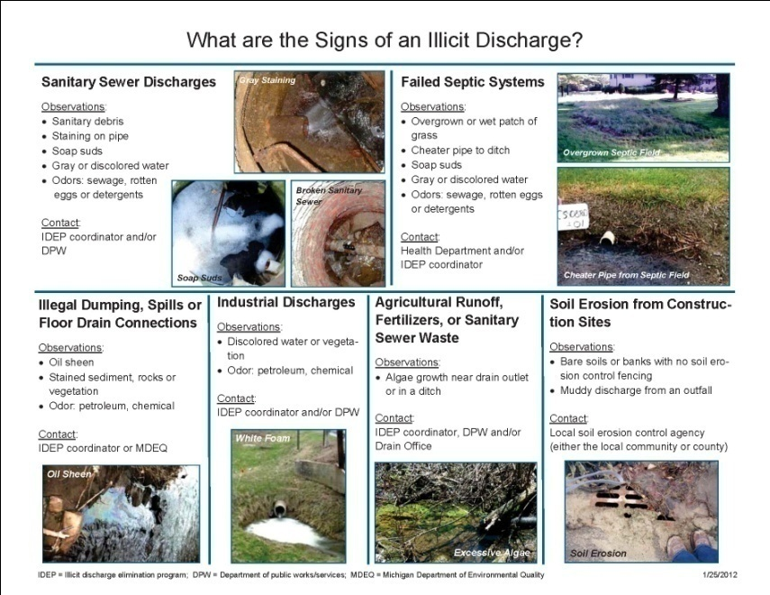
Schedule: PEP subcommittee/ Tetra Tech will have brochure complete by July 1, 2014 for distribution.

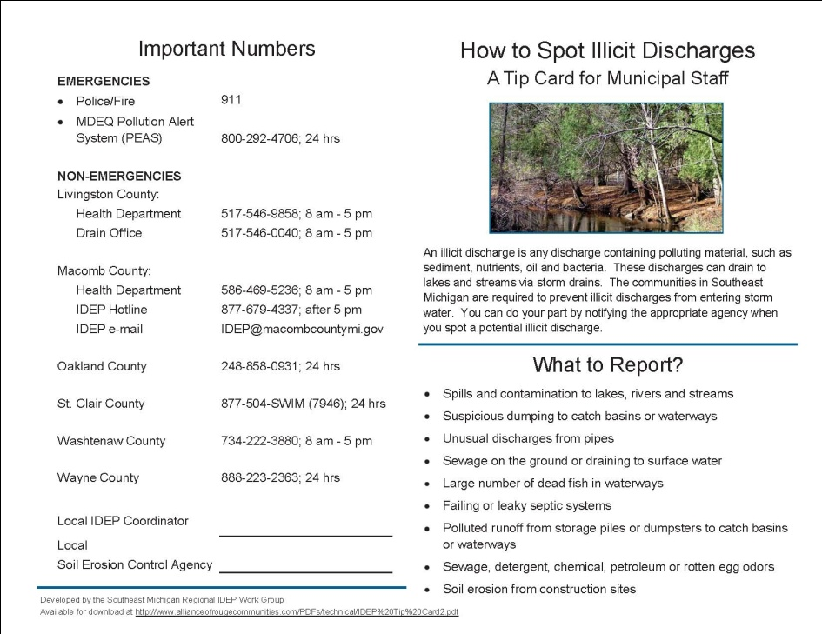
Attachment “D”
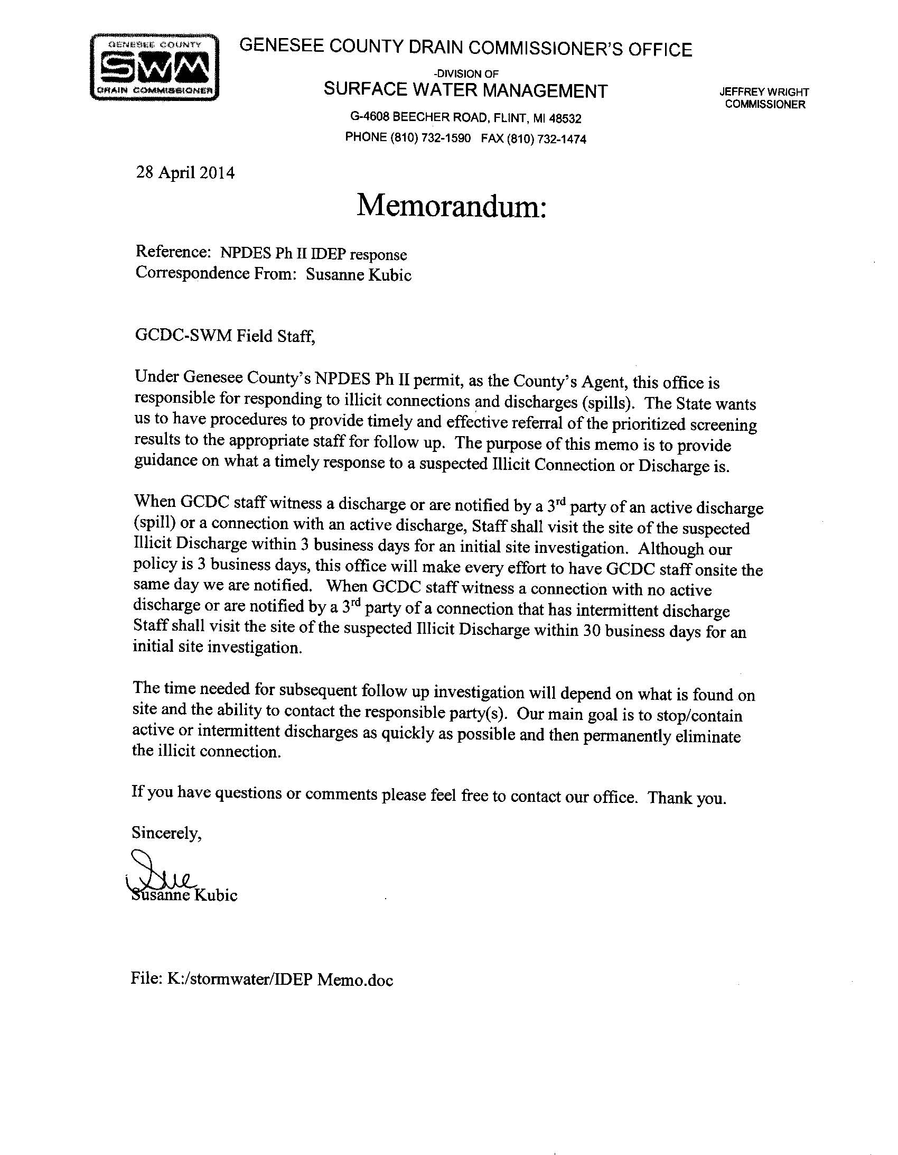

Attachment “E”
Spill Notification Complaint Reporting Form
